Christians Against Poverty St Austell, Review 2023

As I reflect on the ministry of CAP over the past 12 months, may I take this opportunity to wish you all a happy, healthy and blessed 2024. My calendar reading on 1st January was a timely reminder once again of the Lord’s presence with us from Joshua chapter 1 verse 9
‘Have I not commanded you? Be strong and courageous; do not be discouraged, for the Lord your God will be with you wherever you go’.
I take heart from this that the Lord will indeed go before us, he has divine appointments for us, and I can rest in Him knowing that each door we go through He is there in front of us, preparing the way and preparing the hearts of people we have yet to meet. He will give us the words we need in the hour that we need them to give advice, support and comfort, especially needed in this time of uncertainty and financial crisis.
In 2023, CAP commissioned a YouGov poll to discover more about the reality of living in poverty in the UK. The poll revealed that 16 million people have been forced to skip meals as they could not afford them. It also found that half of all adults (25 million people) went without heating at some point last winter as they couldn’t afford the energy costs and 6 million went without heat on a daily basis as a result of poverty.
The seemingly unending pressure of financial insecurity has a detrimental impact on people’s wellbeing and mental health; even a small, unexpected expense can push them over the edge into debt.
The theme of our CAP Sunday in October was ‘Compassion in Action’. During our gathering at White River Community Church (WRCC), we heard the story of Melinda. She had been deeply affected by the cost of living crisis. Melinda had to stop work 30 years ago due to mental ill-health and as the cost of living went up, Melinda found it impossible to make ends meet and found herself spiraling into debt. Melinda found hope and transformation through the compassion of the local church. She contacted CAP and was visited by a CAP debt coach who offered practical and holistic support. She was able to become debt free through a Debt Relief Order (DRO) and is now a CAP befriender, passing the hope and love she received on to others, truly compassion in action.
There are many stories like Melinda’s and since we launched CAP in the St Austell area in September 2020, 23 of our families are free from debt. During 2023, I received 22 new referrals for debt help, sadly, not all of these folk engaged or saw the process through, but I am overjoyed that during the year, 12 families became debt free, two of these heard the wonderful news the week before Christmas. I had a message from one of them:
“Amazing news, thank you so much for all of your help, support and patience. We are so grateful. Have a beautiful Christmas and a blessed new year”.
Not only have we been supporting folk with their debt, but we have been able to purchase a refurbished washing machine and a refurbished cooker for 2 of our clients, one through ACTS435 and the other through local CAP donations. Both items were purchased from The Lighthouse in Bodmin, and I have to say their service to our clients has been wonderful, they included delivery, fitting and the removal of the old appliances in their price! I have continued to issue a number of Foodbank vouchers to our clients and I am so grateful to our friends at St Austell Foodbank and to all who generously donate to this vital cause. I have also completed emergency food shops for folk when the Foodbank isn’t open and issued a number of electricity top-ups. CAP Debt Help does not just help with debt.
I continue to feel such gratitude towards everyone who has given prayerful, practical and financial support to this ministry. This work would not be possible without our wonderful befrienders who freely give up their time to accompany me on visits and give ongoing practical and moral support to members of our CAP family. Some of the support given has been helping with house clearance, cleaning and moving, accompanying people to hospital appointments and meetings with their bank. It can be inviting folk to meet up for a cuppa or to come along to local church events such as a church fete or breakfast or just keeping in touch with phone calls and messages. I was delighted when one of our chaps attended the Men’s Breakfast at WRCC and attended our Sunday service the following day. I gave this gentleman a New Testament and Psalms at Christmas and he thanked me specifically for this during a phone call. Please pray for ‘S’ that the seeds sown will bear fruit.
It was a joy to see one of our debt free families come along to our Light Party at WRCC. I am so grateful to God to see this precious family thriving after all their struggles.
Many of you may be aware that our ministry will be expanding this year as we welcome Craig Glanville from Clays Community Church (CCC) as a new Debt Coach. Craig has been volunteering as a befriender, and has just completed his initial Debt Coach training. God willing, he will be ready to see his first CAP client towards the end of January. Please remember Craig in your prayers. I have been much encouraged by the way that members of CCC have embraced the CAP ministry and have a number of new befrienders there supporting our CAP family in the Clay villages.
I continue to have a presence at the St Austell Support Hub, which usually takes place every 3rd Thursday at The Light & Life Centre between 10am to 12 noon. As well as finding company, a warm drink and free lunch, people have the opportunity to receive advice from a number of local and national organisations to help with the cost of living. Last year, I was also invited by the Clays Practice to attend Community Hubs on a monthly basis in Bugle and St Dennis. The Hub in Bugle takes place in their village hall on the first Tuesday of every month between 11am and 1pm, and at ClayTawc in St Dennis on the 1st Wednesday of every month, 11am to 1pm. Through these Hubs, a number of folk have made appointments with CAP for Debt Help and I have been able to sign post people to CAP Lifeskills and other relevant organisations as well as networking to resolve a number of issues for our families with South West Water and Cornwall Council.
In July last year, I was invited to attend a ‘Work and Wellbeing’ event at St Austell Jobcentre where I had a number of useful conversations with those needing support with budgeting and debt. It was also a great opportunity to remind Jobcentre staff of our service and give an awareness of CAP Debt Help to representatives from other organisations in attendance.
Leading up to Christmas, I was amazed by the generous gifts from individuals, local churches and service organisations for our CAP families. The members of Holy Trinity Church, St Austell donated enough funds to provide a beautiful bag of gifts for each child within our families and care packs / gifts for our single chaps, beautifully presented by Lesley and her team. St Lukes, Boscoppa gifted supermarket vouchers, which helped to feed 11 of our families over Christmas, while St Austell Bay Rotary donated vouchers to be used at our local butcher and greengrocer, which helped feed more families. Members of CCC donated groceries and warm blankets for the families we support in the Clay villages and St Austell Foodbank (curtesy of Pengelly’s Garden Centre) donated a further 3 Christmas food hampers along with festive treats for our larger families. Each family had a Christmas card with a gospel message and for individuals who had not already received one, a New Testament and Psalms (kindly donated by Good News for Everyone) was included in their hamper. It was a busy week leading up to Christmas ensuring that we delivered all these donations and gifts to very grateful families and individuals, 22 deliveries in all. Thanks go to Wendy (CCC) who helped with deliveries in the Clay area and to my husband Gerald, who helped me over the 3 days. It was a very moving and humbling experience, especially delivering to one of our older gentlemen who was in tears with gratitude. Here are some of the messages of thanks I have received, which go to all who contributed in any way:
• I cannot thank you enough for your generosity! Merry Christmas and God bless you.
• Thank you …., very much appreciated and for all the help getting me straight. I wouldn’t be where I am now, so thank you all and I wish you all a Merry Christmas and Happy New Year.
• Thank you sooo much, Merry Christmas to you and your family.
• Thank you so much, I really appreciate it. Enjoy your Christmas.
• Thank you so much for all of your help and thank you so much for *****’s gifts and our voucher. It is so incredibly kind and really does make such a huge difference to me and *****, have a wonderful Christmas.
• Thank you so much! Hope you have a lovely Christmas.
• Thank you soo much for everything, I hope you and your family have a wonderful Christmas.
Please continue to pray for our CAP ministry as we seek to support more people who find themselves in unmanageable debt during 2024. Already I have four new clients booked in for their Initial appointment during January and February and I am sure there will be many more to come. It would be amazing if this ministry wasn’t needed but while it is, it is helpful to remember the parallel of the debt paid in full by Jesus on the cross for us all, and to make the most of every opportunity we have share this good news with those precious souls that have not heard.
‘The Lord your God in your midst, the Mighty One, will save: He will rejoice over you with gladness, He will quiet you with His love, He will rejoice over you with singing’. (Zephaniah chapter 3 verse 17)
May we move forward in faith. May God’s song over our lives drown out any lesser voice. May we look up and rejoice because heaven rejoices over us. In Christ Jesus we possess all we need. Our names are written on His hand. Our desires are especially close to His heart. His call on each of our lives fits each of us perfectly. Be watchful and thankful, Jesus is with us. Amen.
Thank you and bless you all,
Edwina
.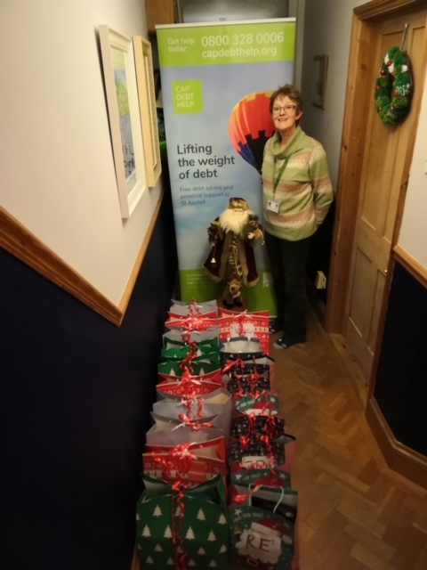
Children’s Christmas presents and chaps’ care packs ready for delivery.

